CalSAWS Call Log data analysis

# Initial data
A dataframe of call data from CalSAWS containing the following fields was uploaded for analysis:
- Case ID
- Person ID
- Date/Time
- Call Source
- Action Required
- Primary Call Reason
- Other Reason
- Call Log Type
Total record number is 61,747.
Since only incoming calls are of interest for this analysis, records with an empty “Call Source” field or containing the value "Outbound Interactive Voice Response (IVR) System" were removed from the source data.
The remaining sample contains 29,347 records and covers the period 2/27/23 through 4/24/24.

# Explore the data
Distribution of the calls number by dates:
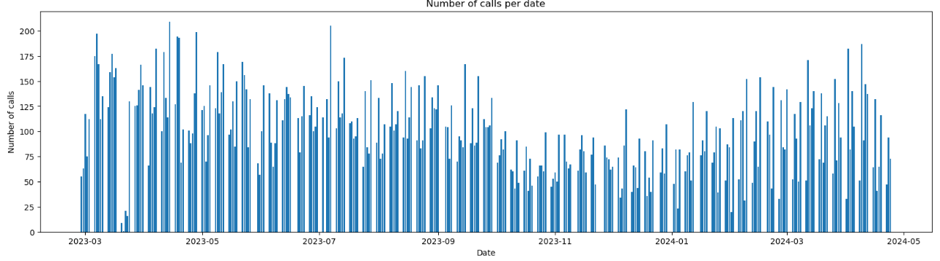
Distribution of the calls number by days of week:
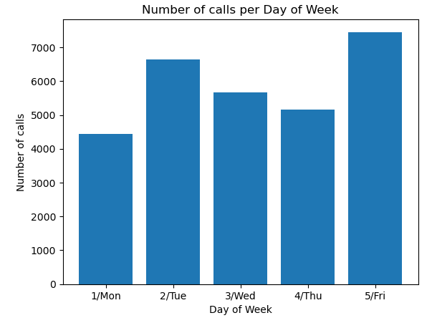
Based on the amount of raw data available, the distribution of the calls number by week seems to be the most informative:
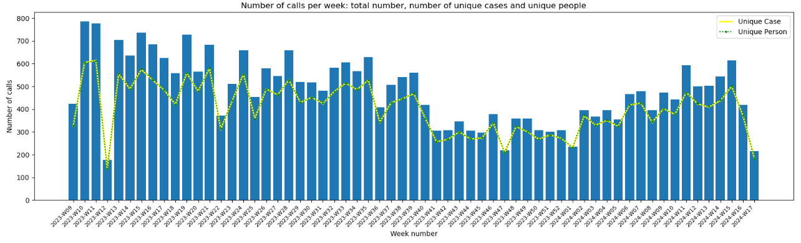
The graph above additionally shows the number of calls by unique case numbers and by unique persons (these data are almost the same).
Since there are quite a few gaps in the raw data for one or another of the call parameters, it would be interesting to see the amount of data available for each of the parameters:
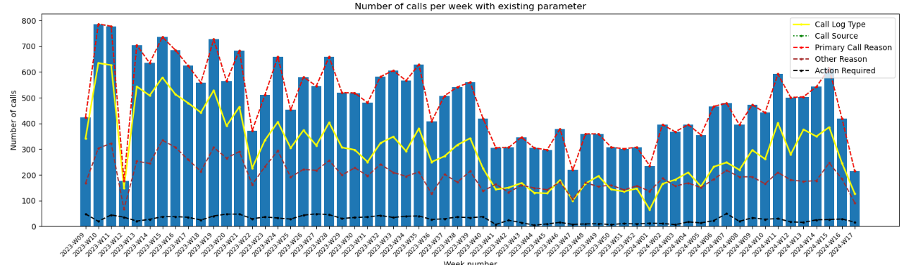
This graph above shows that only the "Primary Call Reason" parameter is present in all calls. The rest of the parameters (Call Log Type, Call Source, Other Reason, Action Required) are filled in, at best, in about half of the calls.
Thus, it makes sense to further investigate the data according to the "Primary Call Reason" parameter.

# Explore “Primary Call Reason” parameter
The distribution of the calls number according to different “Primary Call Reason” values is as follows:
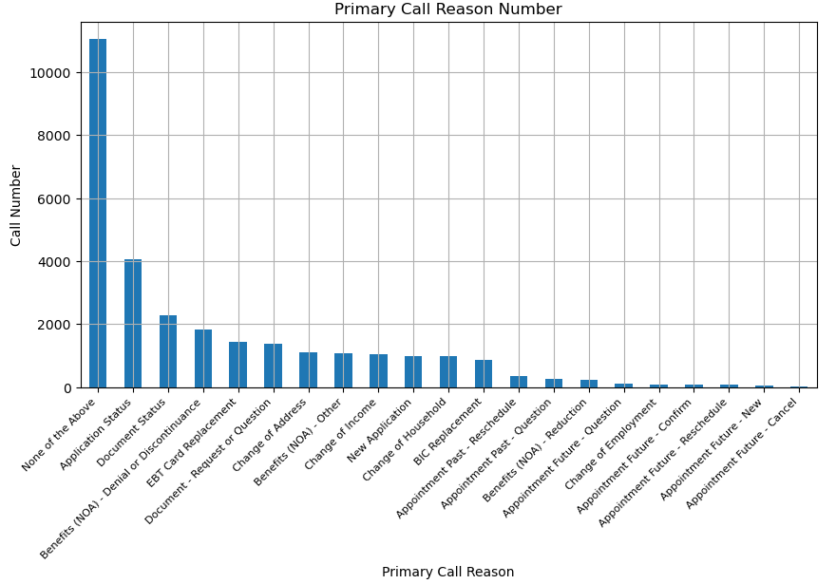

From this distribution, we can see that “Primary Call Reason” = “None of the Above” accounts for more than a third of all data (11,053 / 29,347 = 37.66%).
For the analysis of the “Primary Call Reason”, this value is most likely insignificant and therefore should be excluded. After excluding the "None of the Above" value, 18,294 records remain to be analyzed.
The new plotting of the distribution of the calls number by week shows that the structure of the data has not changed significantly after exclusion:
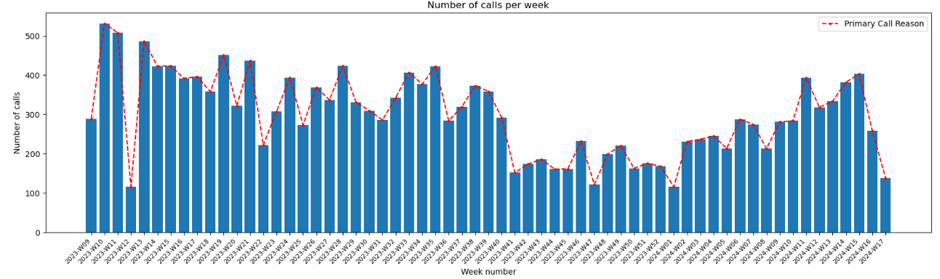
The corresponding distribution by dates also looks like before:
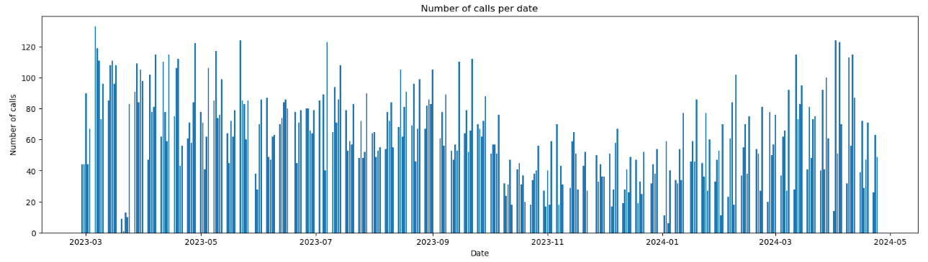
The histogram of the calls number by date is as follows:
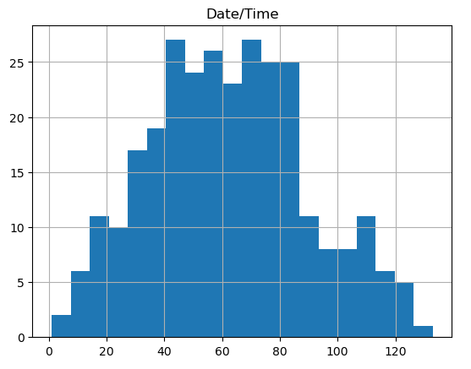
A histogram is a visual representation of the distribution of quantitative data using bars of different heights. Each bar represents a range of values, called a bin or class, and the height of the bar indicates how many data points fall within that range.
In this case, the histogram shows that the most probable number of calls per day is about 40 to 90, with an uneven decrease both downward (up to 0 calls per day) and upward (up to 130 calls per day).
This picture already looks like a decent probability distribution, which we can further work with. Although, of course, for more accurate prediction we would like to have an order of magnitude more records than 18,294.

